**RINEX TECHNOLOGIES**

**MAJOR PROJECTS**

**NAME – DEBASISH DUTTA.**

**BRANCH - ELECTRONICS AND COMMUNICATION ENGINEERING.**

**YEAR - 4TH YEAR (7TH SEM).**

**COLLEGE - SWAMI VIVIKANANDA INSTITUTE OF SCIENCE AND TECHNOLOGY.**

**ACKNOWLEDGEMENT**

Success of any project depends largely on the encouragement and guidelines of many others. I take this sincere opportunity to express my gratitude to the people who have been instrumental in the successful completion of this project work.

I would like to show our greatest appreciation to **Mr. AMEEN MANNA**. I always feel motivated and encouraged every time by his valuable advice and constant inspiration; without his encouragement and guidance this project would not have materialized.

The guidance and support received from all the members and who are contributing to this project, was vital for the success of this project.

**MAJOR PROJECT -1**

**APPLY A CLASSIFIER/REGRESSOR**

**DATASET**

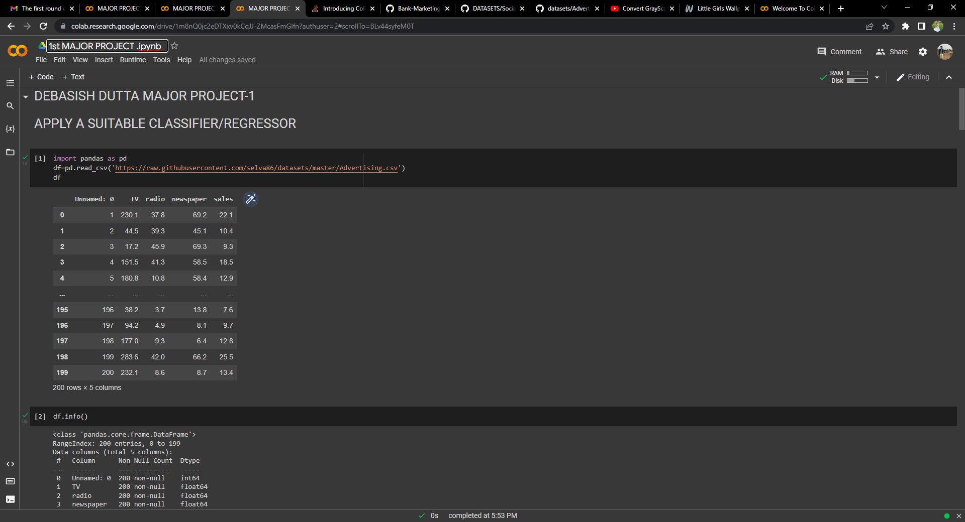[**https://raw.githubusercontent.com/selva86/datasets/master/Advertising.csv**](https://raw.githubusercontent.com/selva86/datasets/master/Advertising.csv)

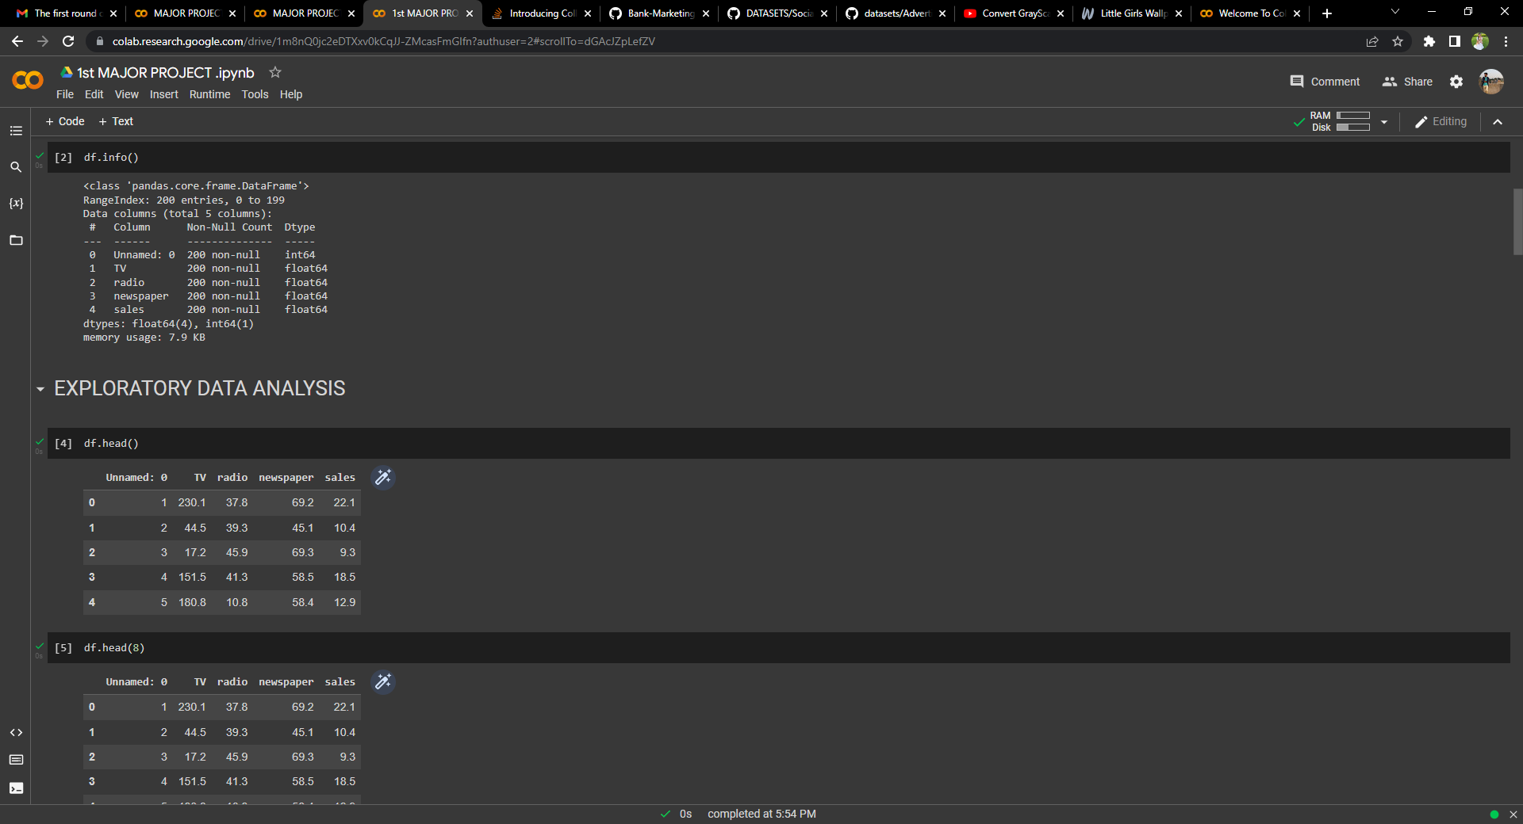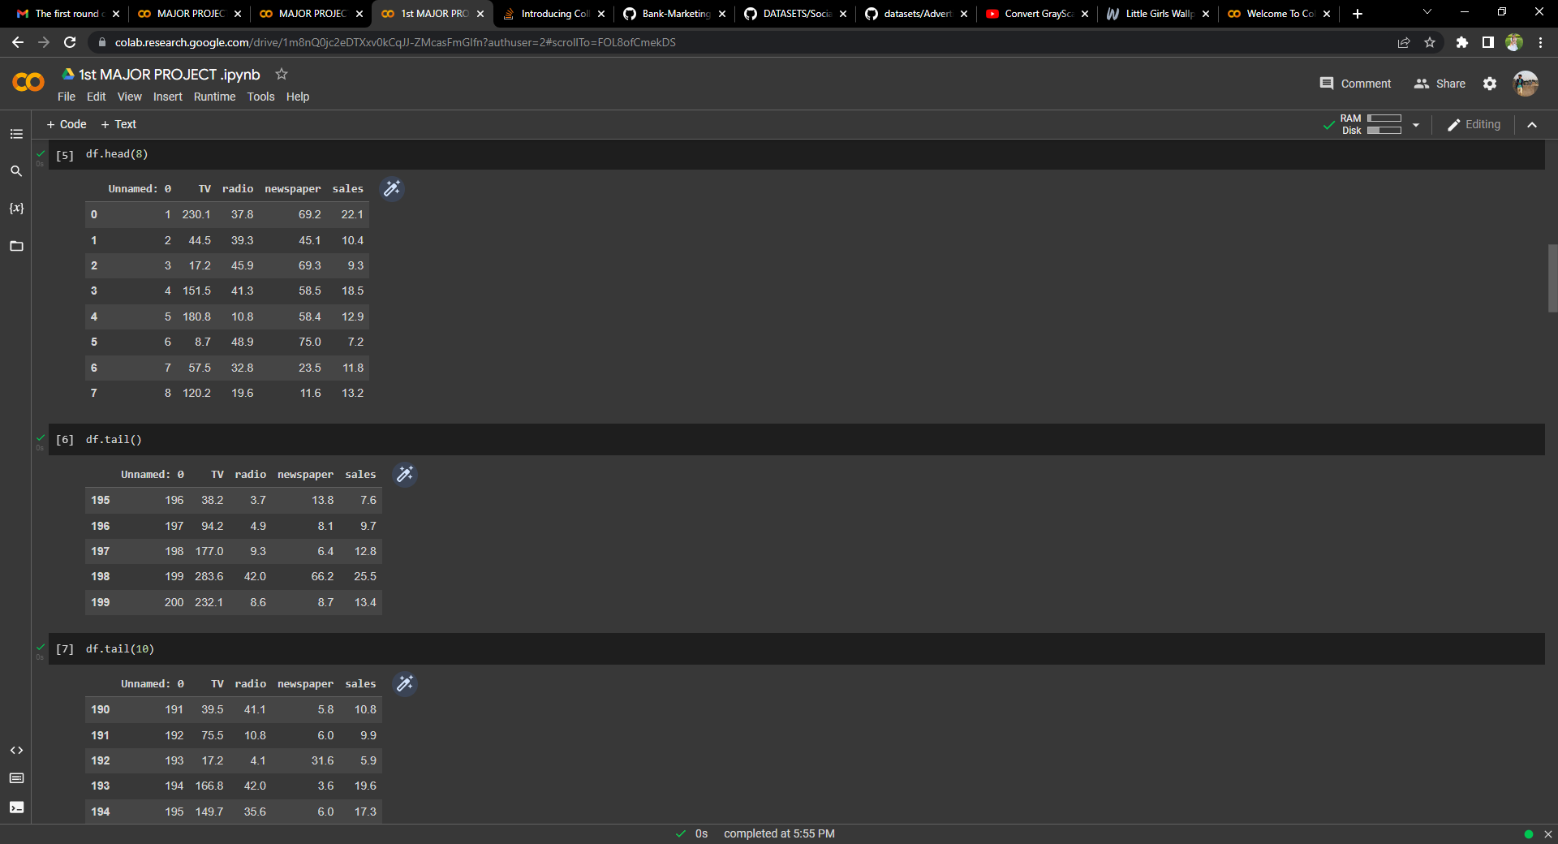

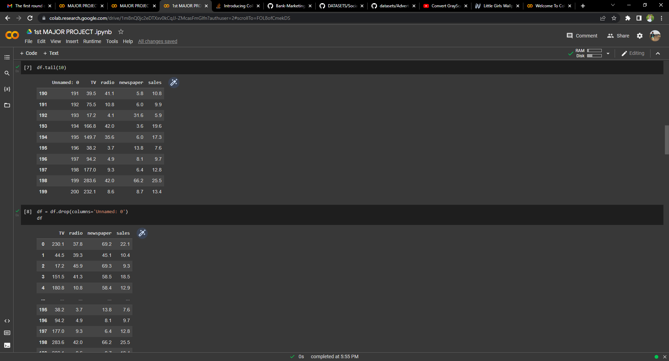

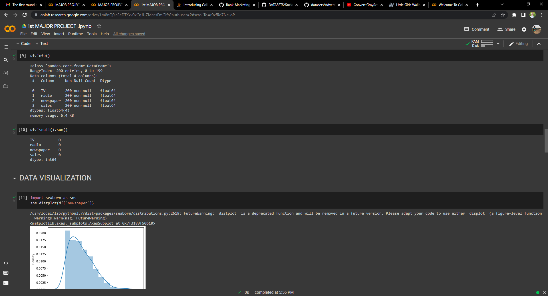

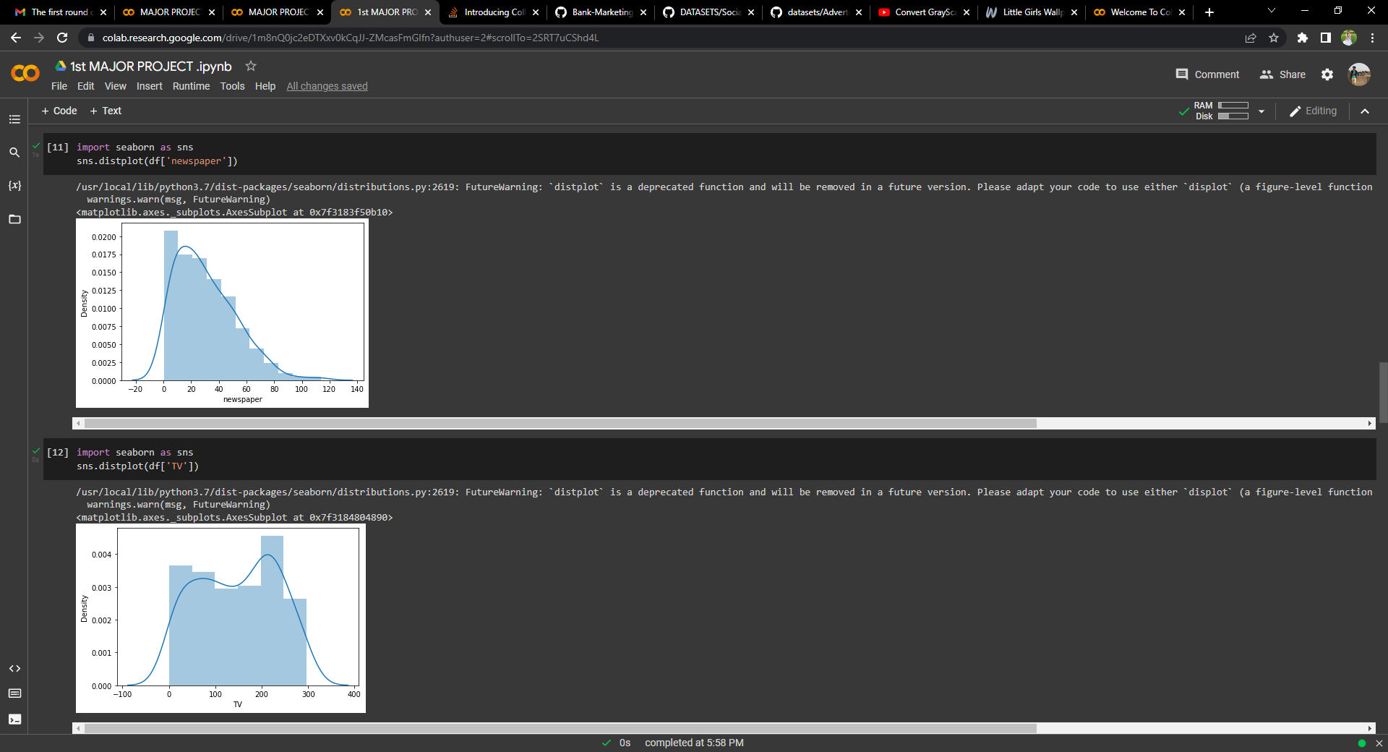

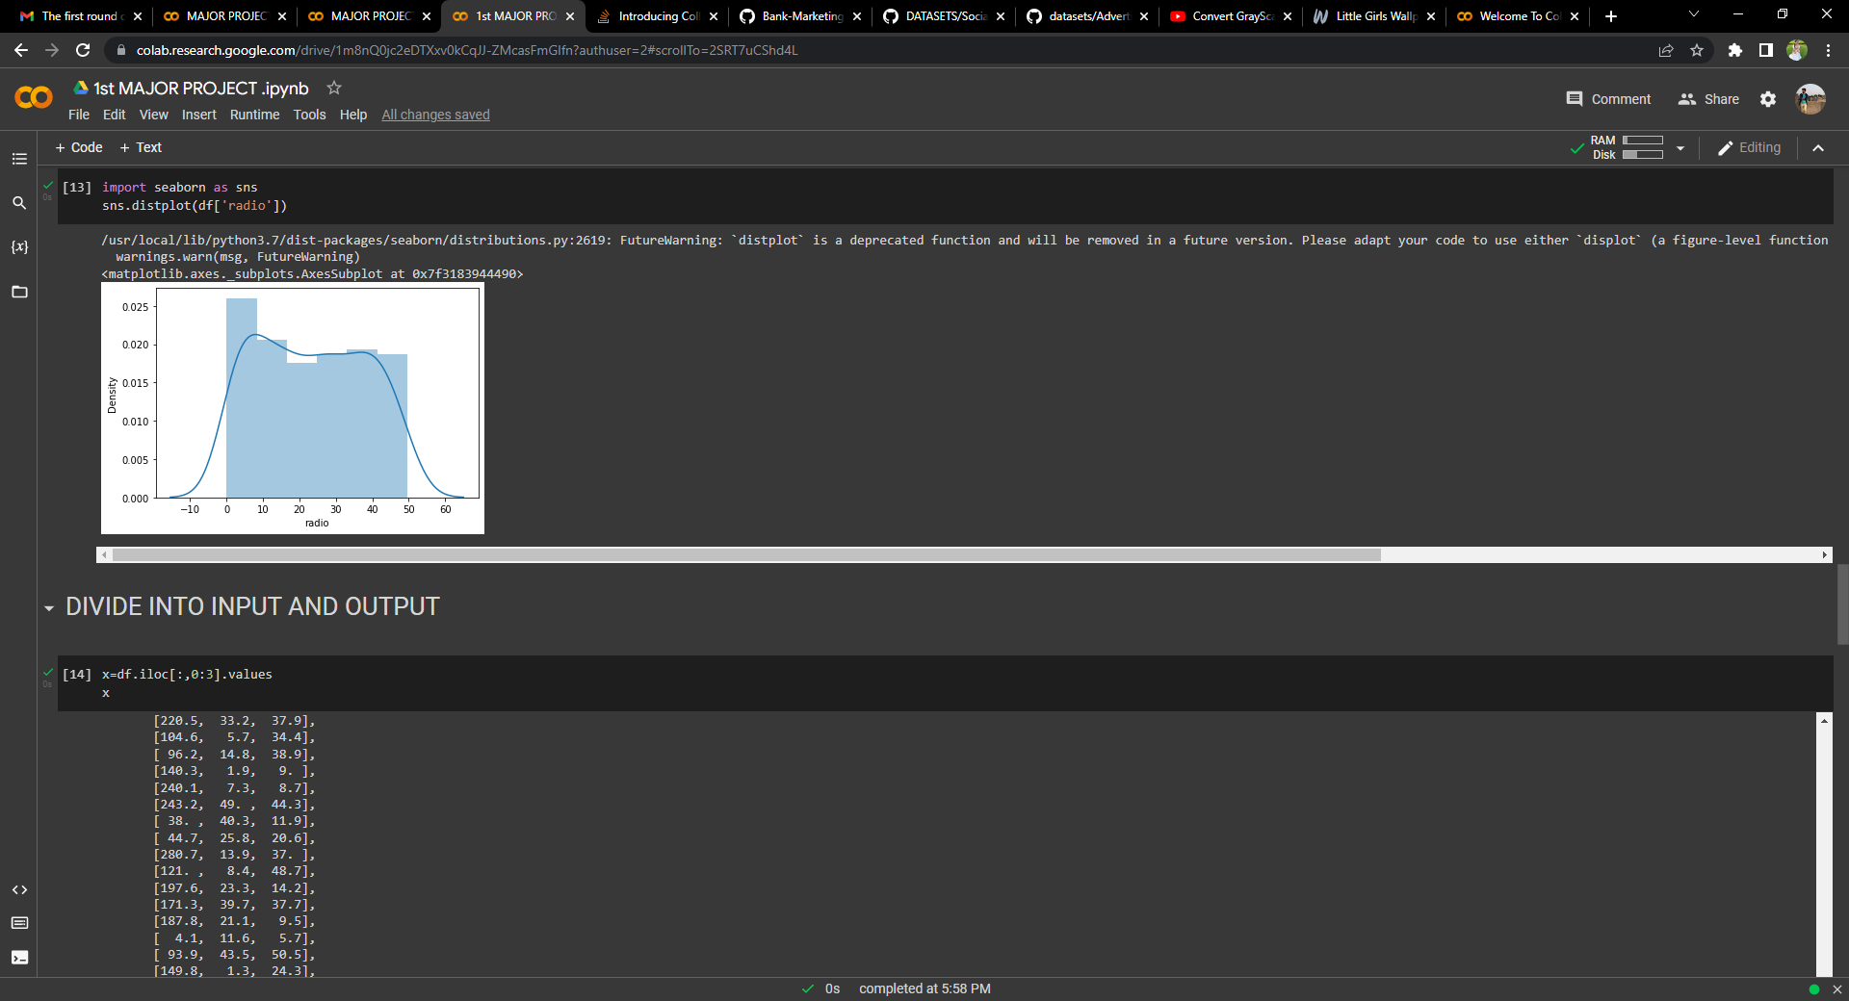

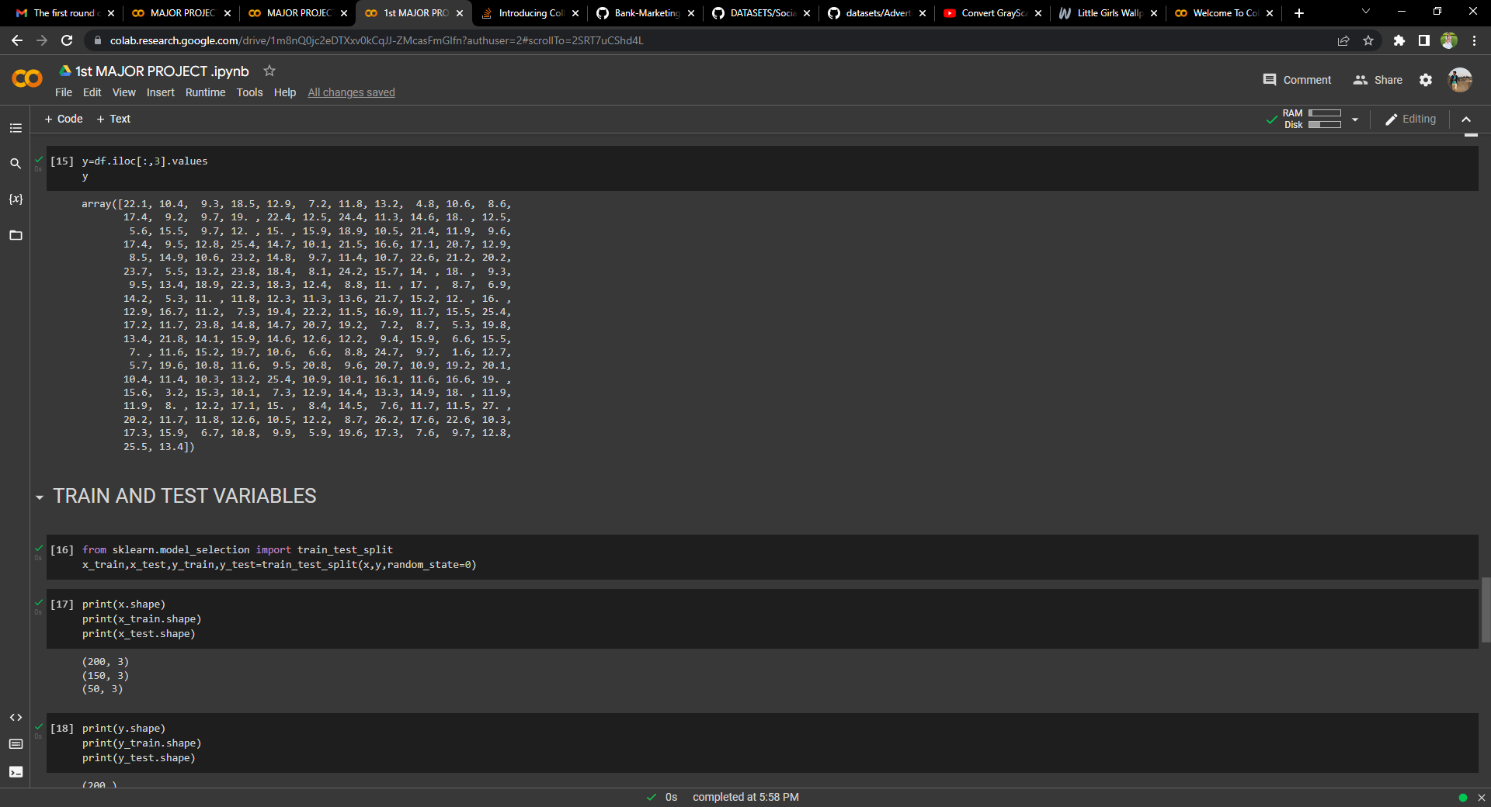

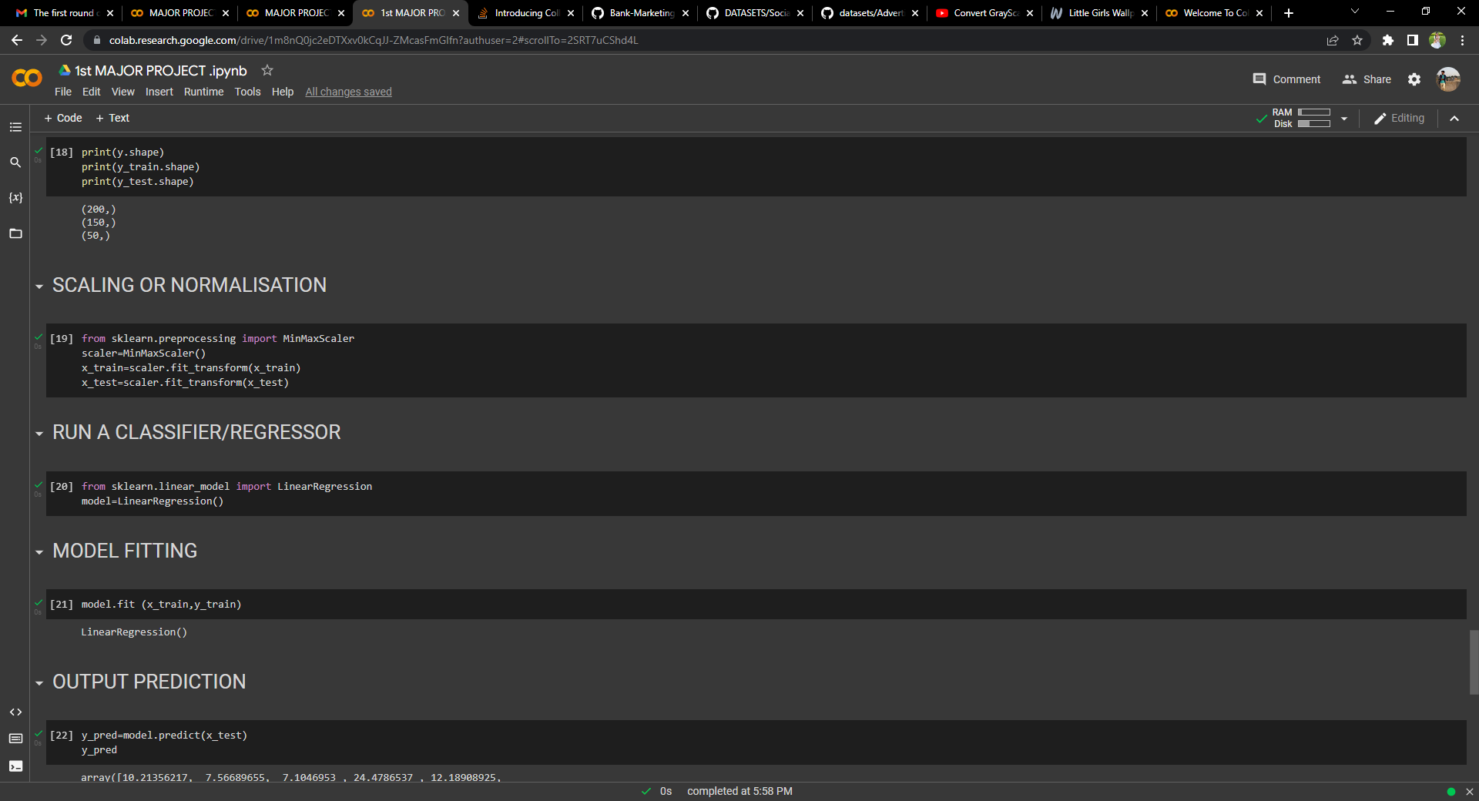

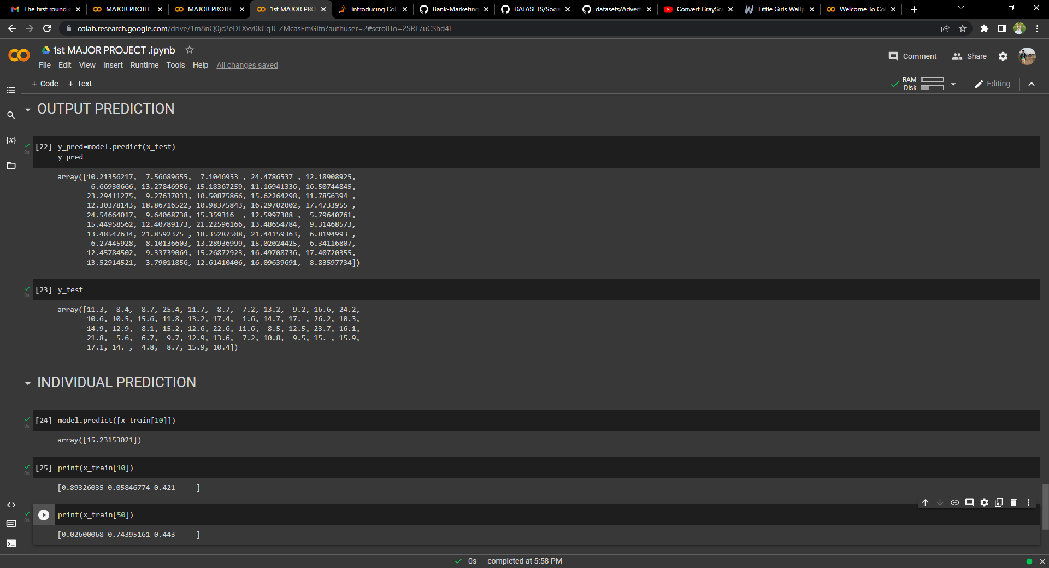

**MAJOR PROJECT-2**

**IMAGE PROCESSING PROJECT ON A TOPIC OF**

**IMAGE CONVERTION**

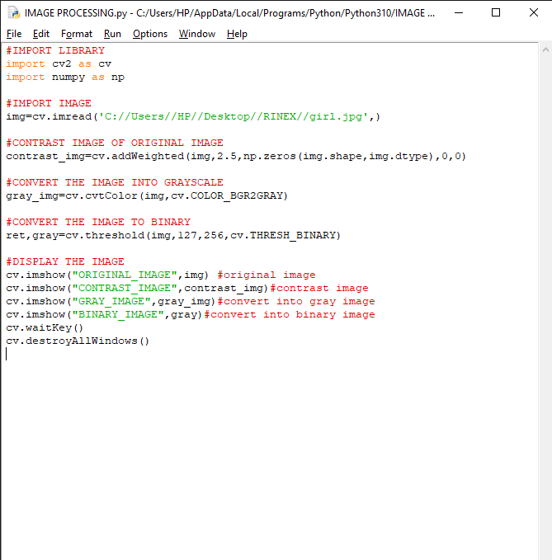



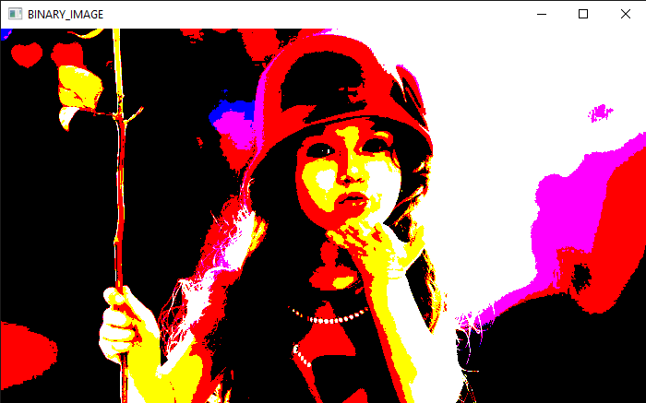

**THANK YOU**

